COMMUNITY LAW RESOURCES ASSOCIATION
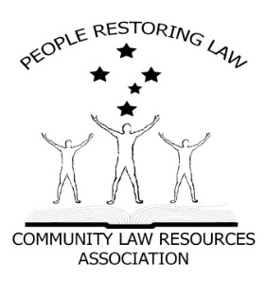 Some Facts.
IS THE WESTERN AUSTRALIA LOCAL GOVERNMENT VALID?

PRESS RELEASE
- All Parliaments require authority from somewhere to make Laws.
- Where does the Western Australian Parliament receive its authority from?
- Answer; the Western Australian Constitution s57 and the Commonwealth Constitution s108.
- The Western Australian Constitution is subject to the Commonwealth Constitution s106.
- Local Government relies on the Local Government Act 1995 (WA) for its existence.
- The Local Government Act 1995 (WA) relies on s52 of the Western Australian Constitution for its existence.
- Municipal institutions and local government, is in the Commonwealth Constitution as a department of a State Government. (Pages 935 & 936 Annotated Constitution).
- In 1979, The Parliament of Western Australian created the Western Australian Constitution to include s52 which inserts Local Government into the Western Australian Constitution.
Some questions.
- Can the Parliament of Western Australian amend the Commonwealth Constitution? NO. Only the people of the Commonwealth can do that by means of s28 (referendum) of such Constitution.

Can the Parliament of Western Australian create any Laws that are inconsistent with the Commonwealth Constitution? NO. s106 & s108 Commonwealth Constitution.
Some more Facts.
- Therefore, s52 of the Western Australian Constitution is unlawful and, as a result, so is the Local Government Act 1995 (WA) and, consequently, so is Local Government as a Government.

- Local Government can only be a Department of a State, and Departments of States cannot govern us, cannot create Laws (Local Laws) and above all cannot Tax us (Rates).

- Municipal institutions and local government are in the Commonwealth Constitution, as a department of a State Government. In 1980, the Western Australian Parliament created its Constitution to include a 3rd or an essential tier of Government, which has effectively altered or is at least repugnant to the Commonwealth Constitution.

Statement
Local Government cannot govern us, cannot make laws for us and cannot tax us.
Municipal institutions and local governments can only be a Department of a State, just like the Education Department or the Health Department.
Now the question for all Western Australian State politicians is: In 1979, where did the Western Australian Parliament get its authority from to alter or at least make laws (their Constitution) that are repugnant to the Commonwealth Constitution?

