Source: https://articles.mercola.com/sites/articles/archive/2022/12/09/big-pharma-takeover-of-modern-medicine.aspx

Has Big Pharma Hijacked Evidence-Based Medicine?
Analysis by Dr. Joseph Mercola Fact Checked December 09, 2022

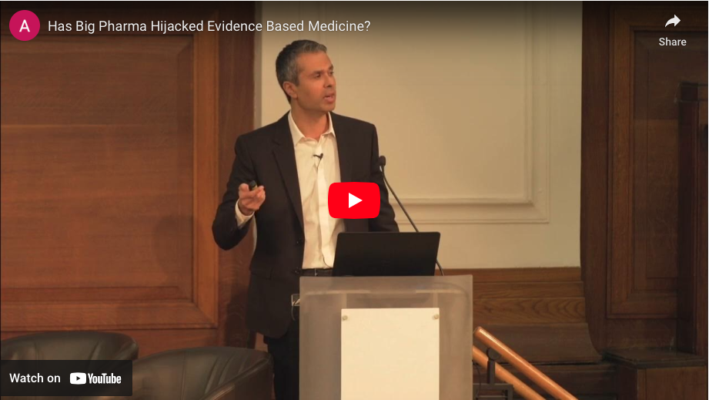
https://www.youtube.com/watch?v=vw7YXUZ1SL0

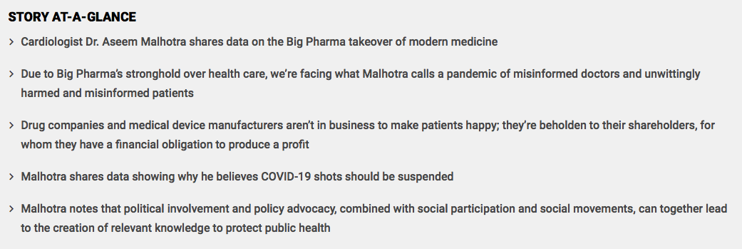
Fear inhibits your ability to think critically. This is a central point made by cardiologist Dr. Aseem Malhotra in his London presentation November 14, 2022. Many people were gripped by unprecedented fear during the COVID-19 pandemic, which shaped attitudes about the pharmacological interventions offered.
Willful blindness is another phenomenon to be aware of. It's when people turn a blind eye to the truth. Also known as conscious avoidance, this tactic has historically been used in legal trials to avoid criminal liability by ignoring or purposely staying unaware of key facts.
However, Malhotra notes, people also engage in willful blindness in order to feel safe, avoid conflict, reduce anxiety and to protect prestige or, in some cases, "precious, fragile egos."¹

The Illusion of Knowledge Is Worse Than Ignorance
Malhotra quoted the late Stephen Hawking, who stated, "The greatest enemy of knowledge is not ignorance, it is the illusion of knowledge."² In terms of health care, evidence-based medicine has been hijacked by Big Pharma; it's now an illusion. There's also an illusion that we're at the forefront of medicine, with prestigious organizations leading the helm, when in reality multiple health crises are upon us.
The World Health Organization's (WHO) definition of health is a "state of complete physical, mental and social well-being and not merely the absence of disease or infirmity."³ Public health, too, is not only about preventing disease, but also promoting health and prolonging life, while helping populations reach the highest possible level of well-being. But are public health agencies actually helping to achieve these goals?
Malhotra, a cardiologist trained by the U.K.'s National Health Service (NHS), as well as a visiting professor of evidence based medicine at Bahiana School of Medicine and Public Health in Salvador, Brazil,⁴ cited a 2020 study published in the British Medical Bulletin.⁵
It used data from the U.K.'s Office for National Statistics from 2010 to 2020, which showed a "dramatic slowdown in life expectancy and diverging trends in infant mortality in the UK as a whole and England and Wales, respectively." Health trends in the U.K., the study concluded, "are worrying and raise important questions about government policies."⁶
Throughout his career, Malhotra has tried to call attention to failures in treating heart disease. "Despite so-called modern science," heart disease remains the No. 1 cause of death globally.⁷ "So clearly there's something that we've done wrong on that front," Malhotra said.⁸
More recently, he's focused on using real evidence-based medicine to share the truth about COVID-19 mRNA vaccines. His two-part paper on the topic was published in the Journal of Insulin Resistance, specifically,^{9,10} because this journal does not accept money from the pharmaceutical industry.¹¹

A Pandemic of Misinformed Doctors and Patients
Due to Big Pharma's stronghold over health care, we're facing what Malhotra calls a pandemic of misinformed doctors and unwittingly harmed and misinformed patients. This misinformation comes from a variety of sources, including:¹²
Biased funding of research — Research funded because it's likely to be profitable, not because it's likely to be better for patients | Biased reporting in medical journals
Biased patient pamphlets | Biased reporting in the media
Commercial conflicts of interest | Defensive medicine
Medical curricula that fail to teach doctors how to comprehend and communicate health statistics
Malhotra describes John Ioannidis, professor of medicine and professor of epidemiology and population health at Stanford University, as the "Stephen Hawking of medicine."¹³ Ioannidis cowrote a paper in 2017 titled, "How to Survive the Medical Misinformation Mess."¹⁴ At the time, he described four key problems:
- Much published research is unreliable, offers no benefit to patients or is not useful to decision makers
- Most health care professionals are not aware of this problem with published research
- Health care professionals lack the necessary skills to evaluate the reliability of medical evidence
- Patients and families lack accurate medical evidence and skilled guidance when they need to make medical decisions
The solution, according to Ioannidis, involves focusing efforts on "making health care professionals more sensitive to the limitations of the evidence, training them to do critical appraisal, and enhancing their communication skills so that they can effectively summarize and discuss medical evidence with patients to improve decision-making."¹⁵
Ioannidis also wrote a 2005 paper about why most published research findings are false. Not surprisingly, one factor that makes a research finding less likely to be true is "greater financial and other interest and prejudice."¹⁶

Drug Companies Are Beholden to Their Shareholders
Drug companies and medical device manufacturers aren't in business to make patients happy; they're beholden to their shareholders, for whom they have a financial obligation to produce a profit.¹⁷ There's no legal requirement for them to offer patients the "best" treatment.
Further, regulators regularly fail at their duty to prevent industry misconduct, while doctors and medical journals — which do have a responsibility to put patients' interests and scientific integrity first — collude with industry for financial gain.¹⁸
Recently, Malhotra was heavily involved in campaigning to end NHS COVID-19 shot mandates. But prior to this he spoke to the European Parliament in 2018 to warn them of the epidemic of misinformed doctors and patients, stating, "Honest doctors can no longer practice honest medicine. We have a complete health care system failure …"¹⁹
In fact, in 2016, Dr. Peter C. Gotzsche, cofounder of the Cochrane Collaboration and the Institute for Scientific Freedom, stated prescription drugs are the third leading cause of death — most of them preventable.²⁰ "The reason for that," Malhotra said, "is the information that comes from drug companies — essentially the results of clinical trials — exaggerate the benefits and the safety of the drugs."²¹
Corporate crime and fraud are also rampant — from 2009 to 2014, Gotzsche noted that most of the top 10 drug companies committed fraud, totalling about $14 billion, including hiding data on drug harms and illegally marketing drugs.
Yet, the fines the drug companies had to pay for their crimes were miniscule in comparison to the profits they made from the drugs. Since then, however, nobody was fired and "nothing has changed to stop them from committing these crimes again."²²

Tobacco Tactics Revisited During COVID Pandemic
Malhotra is among those who stated early on during the pandemic that poor diet can increase your risk of dying from COVID-19, by increasing obesity risk, chronic disease and disrupting your gut microbiome.²³ In April 2020, he tweeted, "The government and public health England are ignorant and grossly negligent for not telling the public they need to change their diet now."²⁴
Not only did they not publicly share the importance of healthy weight and diet to ward off COVID-19, but they glamorized and encouraged junk food consumption via their official social media channels. At one point during the pandemic, Royal Free Hospital, which is part of the Royal Free London NHS Foundation Trust, tweeted the following along with a photo showing dozens of doughnut boxes:²⁵
"You guys at @krispykremeUK Enfield sure know how to put a smile on our staff's faces!1,500 doughnuts delivered to our staff at Barnet Hospital-#glazeamaze."
"I've got nothing against people having a treat," Malhotra said. "But hospitals shouldn't be promoting … and essentially advertising the fact that we are giving 1,000 free Krispy Kreme doughnuts to nurses in the middle of the pandemic. I don't think that was very productive considering what we know about the influence on COVID."²⁶
That hospitals were promoting junk food and junk food companies instead of healthy food is reminiscent of Big Tobacco's tactics, which not only suppressed the harmful effects of cigarettes but also recruited doctors to promote them, using slogans such as, "More Doctors Smoke Camels Than Any Other Cigarette."
"We see the same tactics repeating themselves," Malhotra continued. "What Krispy Kreme is doing is using the NHS as a branding opportunity for what are essentially addictive, toxic foods that should just be treats but not part of the regular diet."²⁷

How COVID Shots Were Oversold
Malhotra was one of the first to take Pfizer's COVID-19 shot, and he's double-jabbed. Initially, he was in favor of the shots but a study published in Circulation, which found an increased incidence of inflammatory markers linked to heart attacks in people who'd received mRNA COVID-19 shots,²⁸ gave him pause.
Then, a whistleblower from a prestigious British institution contacted him and said a group of researchers had found inflammation of coronary arteries after the mRNA shot. However, the researchers had a meeting and decided not to share their findings because it might affect their funding from the drug industry.²⁹ He then learned of data from Scotland that showed an unexplained 25% increase in heart attacks.
He went to the media, armed with data, to share his concerns in October 2021, calling for an investigation. It received a lot of attention, but Malhotra was soon targeted by anonymous complaints to a medical organization, which put his medical license at risk. At that point, he decided to gather other experts and critically review the data — then publish the truth.
In November 2020, Pfizer claimed their COVID-19 shot was 95% effective against COVID-19, but this was highly misleading and, according to Malhotra, based on flawed methodology:³⁰
"'Relative risk reduction is a way of exaggerating the benefits of any intervention … which would be in the interest of people trying to sell you something — in this case, the pharmaceutical industry.
So if, for example, you have 1,000 people in a trial that didn't have the vaccine versus 1,000 people that did in the placebo group … you may have two people dying. And in the intervention group, you may have just one person dying. And that's a reduction of 50%. One over two is a 50% relative risk reduction. But actually, you've only saved one life out of 1,000.
So, the absolute risk reduction is only 1 in 1,000. It's a big difference. The guidance has been for many years that we must always use absolute risk reduction in conversations with patients, not just relative risk reduction alone; otherwise, it's considered unethical,' Malhotra said.
The accusation is that governments acted on Pfizer's relative risk figure of 95% efficacy, when the absolute risk was a mere 0.84%. In other words, you'd have to vaccinate 119 people to prevent just one from catching COVID. 'So we were basically sold on something that ultimately, and in retrospect now, was very, very misleading.'"

Big Pharma Provides Majority of Budget for Leading Regulators
If there were ever any doubt that regulatory agencies are captured by industry, consider that significant portions of regulatory agencies' budgets come from the pharmaceutical industry that these agencies are supposed to regulate. For instance:³¹
Australia's Therapeutic Goods Administration — 96% of budget derived from industry | Europe's EMA — 89%
U.K.'s MHRA — 86% | Japan's Pharmaceuticals and Medical Devices Agency — 85%
U.S. FDA — 65% | Health Canada — 50.5%
Data and health advice from these agencies cannot be considered independent or trustworthy when it's clouded by vested interests. What did one study³² — conducted by people who do not take money from the drug industry — find?
It re-analyzed data that led to the original approval of the shots, and subsequent shot mandates, revealing people were more likely to suffer a serious adverse, disability, hospitalization or life-changing event after receiving an mRNA COVID-19 shot than be hospitalized with COVID.³³ Malhotra shared additional facts about COVID-19 shots that are now known based on the best available evidence:³⁴
- COVID-19 shots offer no protection against infection now
- No reduction in COVID mortality
- Natural immunity is very protective
- Shot side effects are nearly three times more likely if you get the shot after having COVID-19
- Unprecedented harms have been reported from the shots
"We have pulled vaccines in the past for much less," Malhotra said. "… This vaccine needs to be suspended completely, pending an inquiry."³⁵ So why haven't you heard about this? It's clear that willful blindness has taken over. Malhotra notes that political involvement and policy advocacy, combined with social participation and social movements can together lead to the creation of relevant knowledge.
"We need to make sure we've got clear, relevant, concrete knowledge in a way that can be disseminated and understandable to the public."
Toward that end, Malhotra states that it's crucial for the integrity of public health for the facts to be acknowledged and for regulators to state that they've changed their minds too. Moving forward, in order to ensure access to real, evidence-based medicine, key changes need to be made, according to Malhotra, including:
- Drug industry should play no role in testing drugs
- Drug industry should not be able to hide raw data from trials
- All results of all trials in humans must be made publicly available
- Regulators such as the FDA and MHRA should not get any money from the drug industry

What Can You Do to Help?
To help enact change, Malhotra is calling for citizen power in the U.K. to use social media, calling for the suspension of mRNA shots. Specifically, he suggests tweeting and sharing the following, which can be tweaked depending on your location:
"My name is … and I call on the Secretary of State for Health, @SteveBarclay to #SuspendTheMRNAjabsnow until the raw data is released for independent analysis."
Further, in order to beat the psychopathic corporate tyranny that has taken over, we must act virtuously, which involves embracing the following to keep moving forward:
- Wisdom
- Courage
- Moderation
- Justice

Sources and References
- ¹ YouTube, Aseem Malhotra, Has Big Pharma Hijacked Evidence Based Medicine? November 23, 2022, 2:43
- ² YouTube, Aseem Malhotra, Has Big Pharma Hijacked Evidence Based Medicine? November 23, 2022, 3:20
- ³ YouTube, Aseem Malhotra, Has Big Pharma Hijacked Evidence Based Medicine? November 23, 2022, 3:41
- ⁴ Dr. Aseem Malhotra, Biography
- ^{5,} ⁶ Br Med Bull. 2020 May 15;133(1):4-15. doi: 10.1093/bmb/ldz041
- ⁷ World Health Organization, Cardiovascular diseases (CVDs)
- ⁸ YouTube, Aseem Malhotra, Has Big Pharma Hijacked Evidence Based Medicine? November 23, 2022, 5:30
- ⁹ Journal of Insulin Resistance. 2022; 5(1): a71
- ¹⁰ Journal of Insulin Resistance. 2022; 5(1): 72
- ¹¹ YouTube, Aseem Malhotra, Has Big Pharma Hijacked Evidence Based Medicine? November 23, 2022, 6:20
- ¹² YouTube, Aseem Malhotra, Has Big Pharma Hijacked Evidence Based Medicine? November 23, 2022, 8:50
- ¹³ YouTube, Aseem Malhotra, Has Big Pharma Hijacked Evidence Based Medicine? November 23, 2022, 9:33
- ^{14,} ¹⁵ Eur J Clin Invest. 2017 Nov;47(11):795-802. doi: 10.1111/eci.12834. Epub 2017 Sep 28
- ¹⁶ PLOS Medicine August 30, 2005
- ¹⁷ YouTube, Aseem Malhotra, Has Big Pharma Hijacked Evidence Based Medicine? November 23, 2022, 12:31
- ¹⁸ YouTube, Aseem Malhotra, Has Big Pharma Hijacked Evidence Based Medicine? November 23, 2022, 12:52
- ¹⁹ YouTube, Aseem Malhotra, Has Big Pharma Hijacked Evidence Based Medicine? November 23, 2022, 13:18
- ²⁰ The BMJ Opinion June 16, 2016
- ²¹ YouTube, Aseem Malhotra, Has Big Pharma Hijacked Evidence Based Medicine? November 23, 2022, 13:45
- ²² YouTube, Aseem Malhotra, Has Big Pharma Hijacked Evidence Based Medicine? November 23, 2022, 14:29
- ²³ Science Daily May 29, 2019
- ²⁴ Twitter, Dr Aseem Malhotra
- ²⁵ Twitter, Royal Free London April 21, 2020
- ²⁶ YouTube, Aseem Malhotra, Has Big Pharma Hijacked Evidence Based Medicine? November 23, 2022, 35:00
- ²⁷ YouTube, Aseem Malhotra, Has Big Pharma Hijacked Evidence Based Medicine? November 23, 2022, 36:00
- ²⁸ Circulation November 8, 2021
- ²⁹ YouTube, Aseem Malhotra, Has Big Pharma Hijacked Evidence Based Medicine? November 23, 2022, 38:50
- ³⁰ Rumble, Safe and Effective: A Second Opinion September 28, 2022, 15:11
- ³¹ YouTube, Dr. John Campbell, WHO, YouTube and funding November 7, 2022, 10:34
- ³² Vaccine. 2022 Sep 22;40(40):5798-5805. doi: 10.1016/j.vaccine.2022.08.036. Epub 2022 Aug 31
- ³³ YouTube, Aseem Malhotra, Has Big Pharma Hijacked Evidence Based Medicine? November 23, 2022, 49:28
- ³⁴ YouTube, Aseem Malhotra, Has Big Pharma Hijacked Evidence Based Medicine? November 23, 2022, 52:15
- ³⁵ YouTube, Aseem Malhotra, Has Big Pharma Hijacked Evidence Based Medicine? November 23, 2022, 52:23

